Add the below design in Department pages 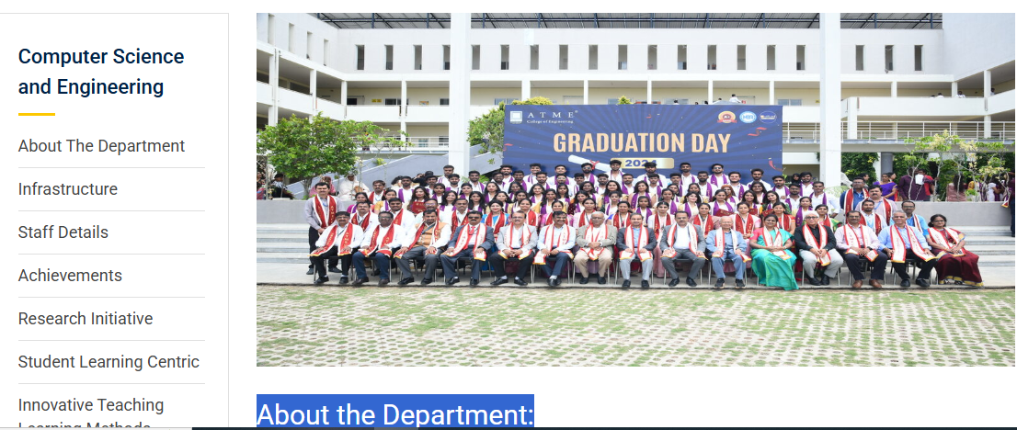

HOD msg

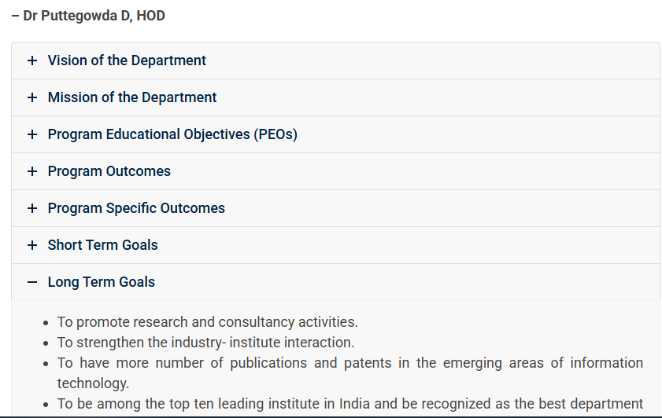

2) 

Name need to be change as **Information Scinece and Technology**

**Facluties**

Tejaswini R.G.

Designation: HOD

Educational Qualification: M Tech

Area of Specialization: VLSI and Embedded System

E-Mail: teju.rg57@gmail.com

##### **Nandashree H M**

Designation: Lecturer

Educational Qualification: M.Tech

Area of Specialization: Software Engineering

E-Mail: nandashree@jsspwmys.org

##### **Asha L**

Designation: Lecturer

Educational Qualification: BE

Area of Specialization: Computer Science and Engineering

E-Mail: [ashal.0708@gmail.com](mailto:ashal.0708@gmail.com)

##### **Nayana K G**

Designation: Lecturer

Educational Qualification: BE

Area of Specialization: Infomation Science

E-Mail: nayana.kg2001@gmail.com

Activity of IS

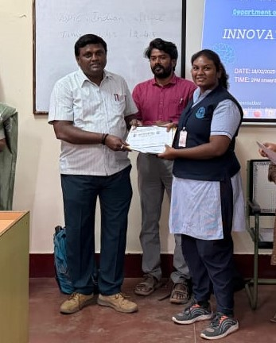

Kum Akshatha of 6th sem IS&T participated in state level “INNOVATION CHALLENGE” organized by Dept of Computer Science and Engg, JSS Polytechnic Mysuru and won first prize

2. Under Dyuthi Student Forum an “Ideathon “was conducted on 18-jan-2025.

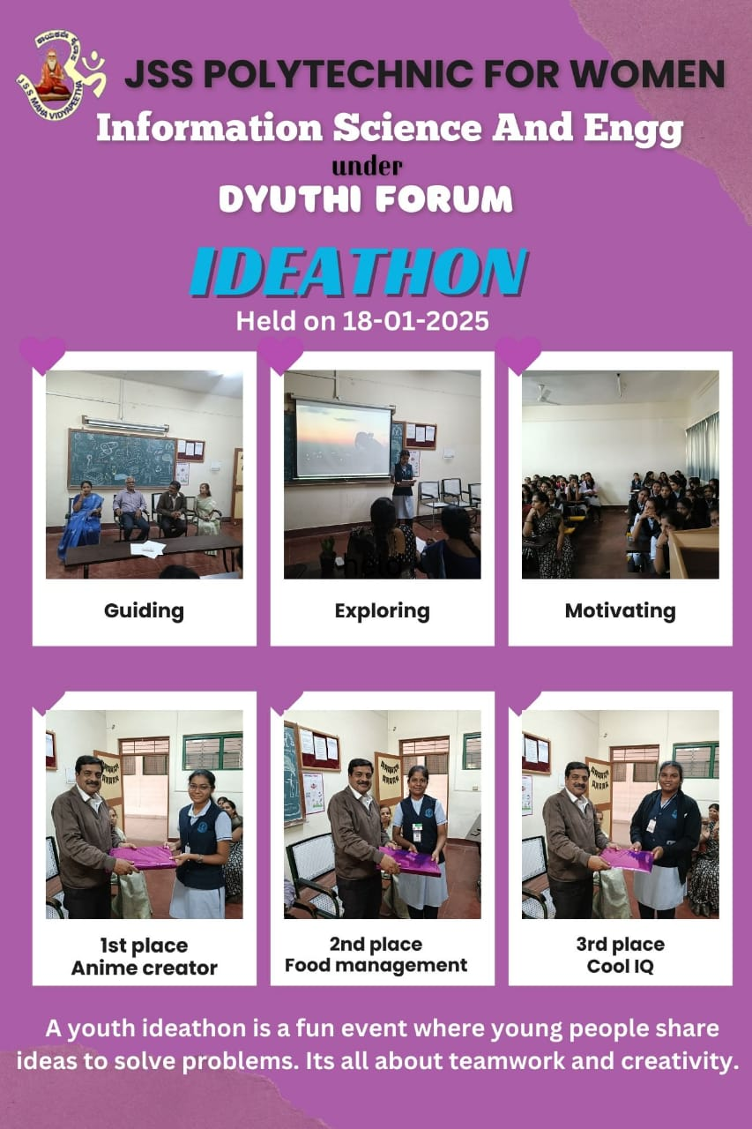

3. A guest lecture on Cloud computing was delivered by Mrs Sudhamani N, Cloud engineer ,Ellucian higher education system on 18 th march 2025 for the benefit of 4th sem students of IS&T

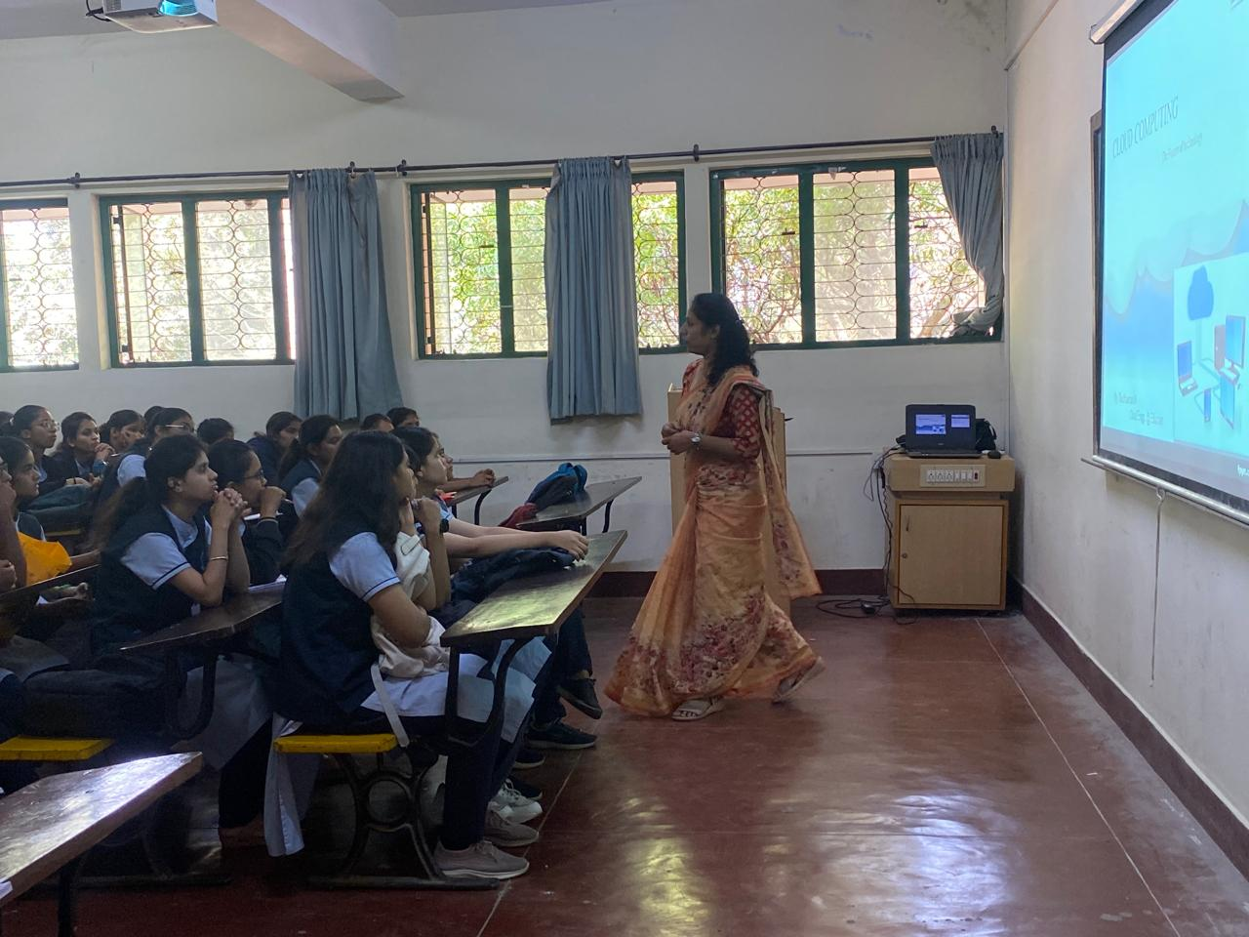

4. IS students won the third prize in National level project presentation computation held by Bharathi Vidhyapeeta college of Engineering, Pune on 12-04-2025 which included 5000rs cash prize

Pdf we shared separately

